Build DANGEROUS DUCK, A Serious PuddleDuckRacer


WORKSHOP #1: PREPARATIONS

About the PD Racer in General

The PD Racer is the brainchild of David “Shorty” Routh who believes that sailing should be a sport that is “cheap, creative, and …fun on the water.” PD Racers are basically 4’ x 8’ box boats or scows that share a common hull up to a height of ten inches. After that, the designs and sail plans are left to the imagination of the builders. The class hull shape is shown on the class rules page: http://www.pdracer.com/class-rules/

Because the PD Racer is an inexpensive, easy-to-build sailboat with minimal class rules, over 600 lb. carrying capacity, infinite design variations, and great sailing ability, the class is expanding rapidly among both novices and experienced boat builders. Constructing and sailing a PD Racer is a wonderful learning opportunity for a parent and child, students, scouts, retirees, or any individual or group that wants to experience the joy of building and sailing a nimble, very stable small boat. That joy is enhanced even further when a group of PD Racers assemble for a messabout, an event that usually includes lots of food, fun, stories, sailing, and otherwise messing about in boats. Each year one of the largest events is the World and Intergalactic Championship which brings together a number of PD Racers and more recently has included notable designers and class racing skippers from Australia, New Zealand. and Canada. Make no mistake, PD Racers can be serious sailing craft. some of these little boats carry over 90 sq. ft. of sail whereas many small prams of similar size carry less than 40 sq. ft. Adventurers have sailed PD Racers 200 miles up the wild Texas coast in the annual Texas 200, completing this challenging event when other larger boats could not. And, in 2012, at least one intrepid PD Racer will take on the Everglades Challenge, a grueling 300+ mile marathon that starts far up the Gulf Coast of Florida and ends in the Florida keys.

Begin your preparations by familiarizing yourself with the rules, records, and registry page for Puddle Duck Racers at Shorty Routh’s website at http://pdracer.com/ Here you will see some of the many variations of Puddle Ducks and perhaps you will even be tempted to try another free plan by a well-known designer. However, although I’m better known for 16 years of polytarp sailmaking, this designer also has about 12 years of experience when it comes to building 4’ x 8’ scows, including a hand in designing and building 10 different Puddle Ducks. You can read about the evolution of my Puddle Duck designs here: http://www.polysail.com/zduck.htm We will discuss more about these new plans in Workshop #2.

Other places where you can get advice and some insights into PD Racers include online forums. Some of the more useful ones include http://groups.yahoo.com/group/60sailing/ While not strictly about Puddle Ducks, the recent 2011 Puddle Duck World Championships were held in Oklahoma, and there are lots of photos, videos, and chatter about PD Racers on this site: http://groups.yahoo.com/group/SailOklahoma/

OK, that was an overly long introduction, but because this workshop could include both novices and experienced PD Racers, I wanted to make certain that I covered all the bases.

About Dangerous Duck in Particular

This PD Racer will combine design elements from #143, the biplane rigged Wild Duck; the #351 Z-PDR, the kit PDR’s that were completed for the Wooden Boat Show in 2010, and some new insights gained from the recent building of a more compact kid’s version of the PDR called Wedgie. Dangerous Duck will have a fairly low freeboard, extended transoms, and be able to sail as either a nearly 100 sq. ft. biplane-rigged PDR or with a 75 sq. ft. battened shoulder o’ mutton sail. The shoulder o’ mutton sail is similar to the smaller 58 sq. ft. double sprit sail that powered the Z-PDR to a 4th place finish in the 2009 Worlds in spite of two 360° penalty turns and a last place start in the final one-lap race. Other sail plans might be made available if builders are interested, but plans and more details will be revealed in the next workshop.

 |  | 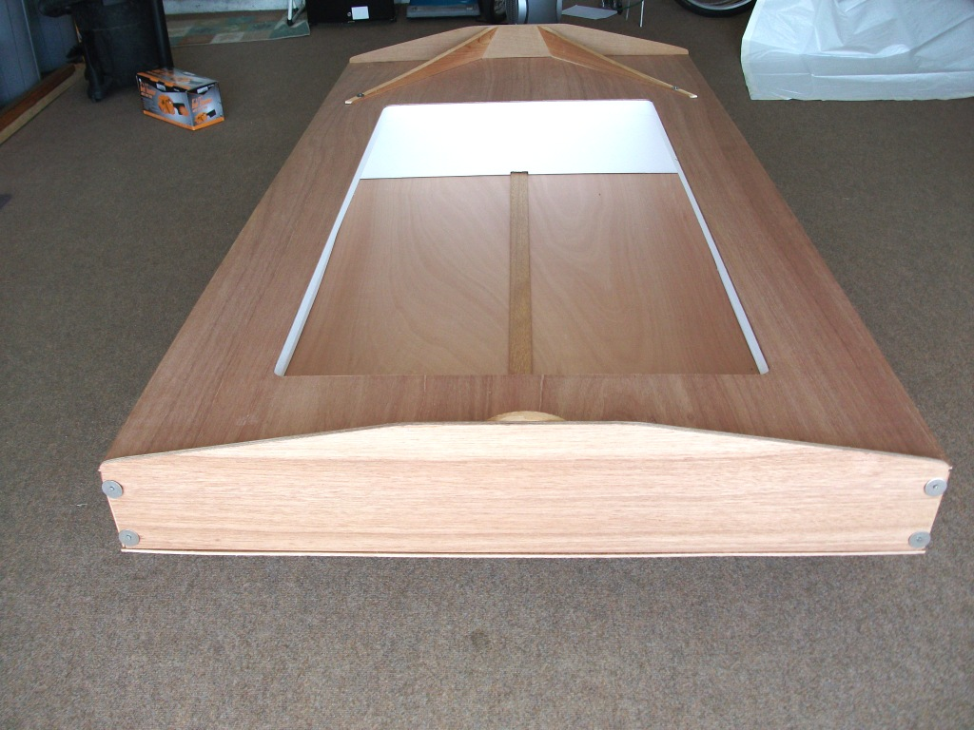
#143 with her original sail plan in the  2009 Worlds. She was updated last summer with windowed sails and numerous other improvements. | #351 headed for the starting line in the 2009 Worlds. | One of two PDR kits preassembled for the Wooden Boat Show in Mystic, CT

Work Space

PD Racers can be built nearly anywhere—in garages, outdoors, in an empty warehouse, in an apartment, in a large tent. Use your imagination. It’s helpful to have a couple of sturdy sawhorses or an old picnic table to hold your work at a comfortable height, but level ground will also do. Utilize a couple of 2” x 4”s to keep your work out of the dirt. Building on a level surface is one key to building a rectangular boat and having the bottom go on easily. So make certain that you continually check your work surface with a level while you are constructing the hull. If you are using power tools with a cord, you will need a power supply and a heavy-duty extension cord. Keep your tools organized and your work space consistently clean and it is more likely you will enjoy your building experience. Don’t forget to observe all tool use safety precautions!

Time Frame

The Dangerous Duck PD Racer will be built at a leisurely pace since many potential builders have numerous obligations that otherwise consume planning and working time. But that’s okay; many home built boats are constructed over the late fall and winter so that they will be ready to enjoy in the spring.

Tools

PD Racers are intended to be easily and inexpensively built with the need for only a few tools and minimal plans. A number of PD Racers have been completed (at least well enough to sail) in less than 24 hours in a process known as a Puddle Duck Hatch. Careful planning for a hatch is essential because the hatch usually involves building a number of boats to a single template or plan within a very limited time frame. In return for publicity, sometimes a local sponsor, such as a building materials store or a community sailing club, can be convinced to donate some of the essential materials and tools for the building process. If you are interested in sponsoring a hatch, ask some of the experienced builders for advice on one of the forums mentioned above.

Tools in the first column below are essential to getting started. Borrow or buy what you need. Tools in the second column are extremely helpful additions you will want to acquire as you continue to build boats. It has been my experience that a person who builds one boat invariably will want to build several more—it’s an addiction. I recommend buying the best tools you can afford, but there are some tools I would just buy from Harbor Freight because they are so cheap and work well. Examples would be the belt sander and two 3/8” 18volt portable drills—one for drilling and one for screwing in screws; or so that you can use one while the other battery is charging. These Chinese-manufactured drills work well and, along with the Chicago Tools sander, usually sell for under $20.00 in one of Harbor Freight’s sale flyers that you can find online.

Minimum Essential Tools | Helpful Additional Tools
- 16’ steel tape measure  - 24” level (4’ is even better)  - Block Plane, at least 7” long  - Clamps (many types can be made inexpensively. See Boat Building in Your Own Back Yard by S.S. Rabl) Spring clamps are available at Home Depot for $.99 each  - Combination square  - Drill and a set of drill bits from 1/16” to 3/8”  - Portable electric jig saw (OK, maybe you could do without this saw, but It sure does save time.)  - Hammer, 12-13 oz.  - Handsaw (You might not need a handsaw if you have the jig saw.)  - Protractor  - 1/10 gal. calking gun for use with PL Premium adhesive  - Sanding block  - Screwdriver, Phillips  - Paintbrush  - Utility knife  - Weights of some kind. Paint cans filled with sand work well as do ½ concrete blocks. | - Adjustable bevel gauge (for copying angles)  - Bench vise  - Carpenter’s wood rasp, Rattail file, Surform tools  - (2) Cordless drills, 3/8” chuck, variable speed, reversible, and additional wood bits  - Circular saw with guide (Good quality cordless circular saws are really great, but expensive. Buy quality saw blades, always)  - Drywall square  - Hammer, 8 oz.  - Handheld belt sander, random orbital sander, portable finishing sander, such as a Craftsman Mouse  - Jack plane, electric rotary plane  - Nail sets/punches  - Power router and bits  - Quick clamps, pipe clamps  - Wood chisels, gouges  - Table saw

These lists are certainly not exhaustive, but they will do to start our build. Wherever possible, I will provide both standard and more costly alternative versions of the Dangerous Duck plans and materials.

Initial Materials for Constructing the Hull and Deck

Decide now whether you want to build an all out lightweight racing PDR or an inexpensive lumberyard version that will still outsail most other PD Racers. Then, over the next couple of weeks, begin purchasing the following materials for the construction of the hull. Some of the fasteners you can probably buy in lower quantities, but they will cost more per individual item, and if you ever build another boat you will save more in the end. If you are using the lightweight cedar framing, you might have to make multiple trips to one of the big box stores to check out new shipments as soon as they are put out on the racks. Clear cedar is a pretty rare find and you might have to substitute something with a couple of knots so long as those knots are not where you will be cutting and are not likely to dislodge. Another option is to substitute a longer or wider board that is knot free, but these other options always cost more. Below is a look at how the side framing is cut for this boat that might help you with board selection among boards that have a few knots. The framing looks to be from a cut out single board, but only the lower portion below the lengthwise middle frame piece is the cut out 8’ x 8” x ¾” cedar board.

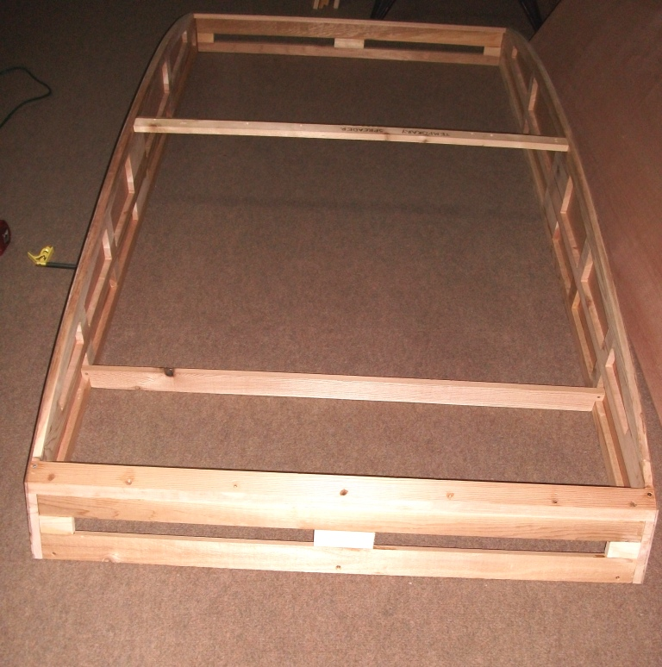 | 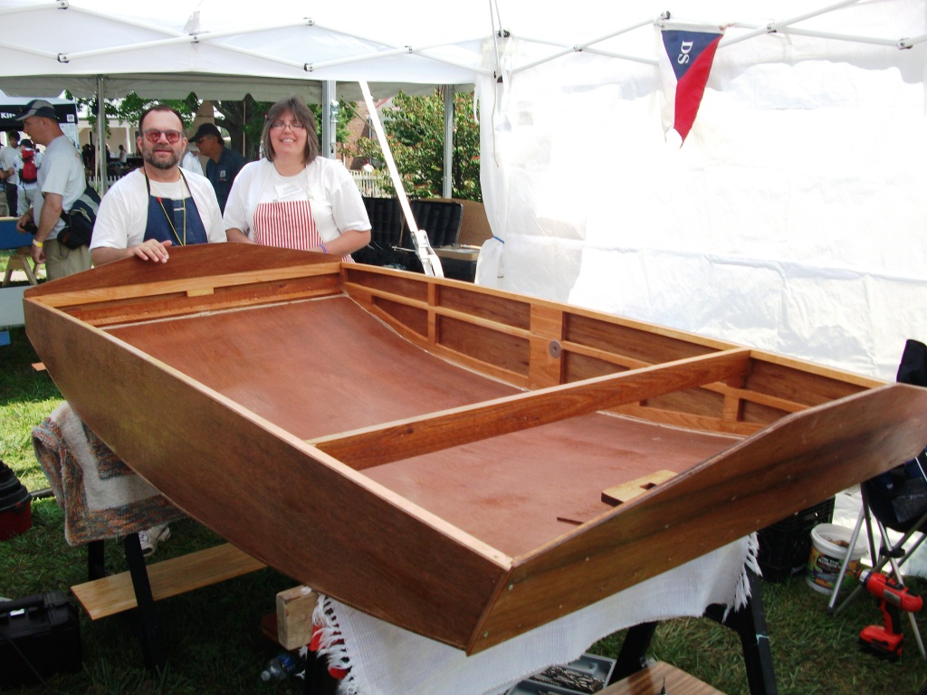
A temporary spreader holds the sides apart at the right width before adding the bottom. | This is a little better view of the type of cedar side framing we will be using. Each side weighs only about 5 lb. in spite of appearances.

LOWER COST VERSION | ALL OUT RACER
- (2) 1” or ¾” x 8” x 8’ clear straight cedar, poplar, or pine (in order of choice)  - (7) 1” x 2” #2 or better straight cedar, poplar, pine, or fir (in order of choice)  - (1) 4’ x 8’ x ¼” AC Plywood Panel  - (2) 4’ x 8’ x 5mm Lauan Plywood Panels  - (1) 4’ x 8’ x 2” Styrofoam Panel  - (2) PL Premium Polyurathane Glue  - (1) 16 oz. Titebond II or III  - 1 lb. of 1 ¼” x #14 #304 stainless steel ring nails from Jamestown Distributors  - Box of 100 1 ¼” x #8 flat head Phillips stainless steel screws from Ace Hardware  - Box of 50 #8 stainless steel finishing washers (cup shaped) from Ace Hardware in a clear plastic box with orange trim, manufactured by Crown Bolt  - (8) 1/8” ID fender washers to be used in temporarily screwing on transoms or other pieces while the glue sets  - If painting your hull, get 1 ½ qt. epoxy kit from Raka at http://www.raka.com/epoxy_kits.html You can use this thinned slightly with acetone as a sealer on the surfaces of the hull, but mix it in small quantities, and work quickly so the epoxy doesn’t set up on you. Painting with acrylic latex is usually the most economical method to finish a hull. | - (2) ¾” x 8” x 8’ clear, straight cedar or poplar (in order of choice, involves lots of sorting at Lowes or Home Depot)  - (7) 1” x 2” x 8’ clear, straight cedar or poplar (in order of choice, involves lots of sorting at Lowes or Home Depot)  - (2) 3 mm Okoume Plywood Panels  - (1) 5 mm Okoume Plywood Panels  - (1) 4’ x 8’ x 2” Styrofoam Panel  - (2) PL Premium Polyurathane Glue  - (1) 16 oz. Titebond II or III  - (1) Package of 100 small (1/8”) bamboo skewers (Kitchen area of WalMart)  - 1 lb. of 1” x #14 bronze threaded annular ring nails from Jamestown Distributors  - Box of 100 1 ¼” x #8 flat head Phillips stainless steel screws from Ace Hardware  - Box of 50 #8 stainless steel finishing washers (cup shaped) from Ace Hardware in a clear plastic box with orange trim, manufactured by Crown Bolt  - (8) 1/8” ID fender washers to be used in temporarily screwing on transoms or other pieces while the glue sets  - If painting, get 1 ½ qt. epoxy kit from Raka at http://www.raka.com/epoxy_kits.html  - If leaving natural use the 1 ½ qt. kit for soaking the hull interior where the sun won’t bleach it out, then purchase the 3 qt. kit with anti-blush and UV inhibitors for glassing the entire exterior and the interior bottom. RAKA also has a number of different glass, cloth, and carbon fiber options. To keep your hull lightweight, I recommend using only 2 to 3.5 oz. glass on the exterior bottom and sides.
END OF WORKSHOP #1

